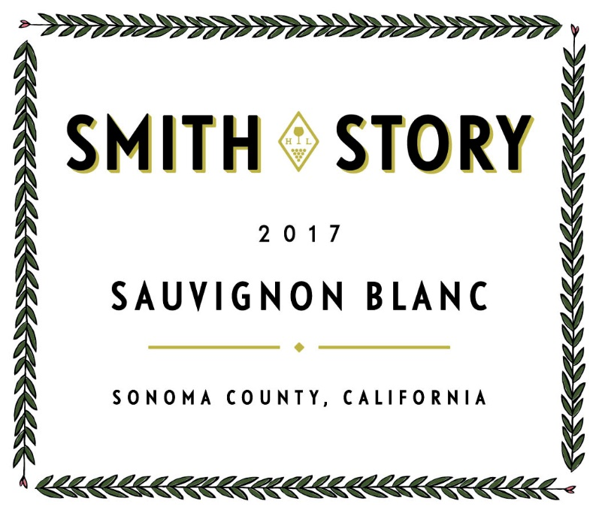
Vineyard Location:
Three single vineyards loacted throughout Sonoma County:
Russian River Valley – Dry farmed and planted approximatly 45 years ago

Vintage
2017 was tough on yields in Sonoma County, our white wine grape harvest came in very light. That said we picked up another vineyard to blend into the wine.

Clone:

Harvest Date:
Septmeber 5 and September 8

Aging:
Whole cluster pressing and fermentation in stainless steel tanks. Each vineyard is vinified separately and blended in later. Aging on lees until botting on February 26.

Production:
835 Cases

SRP:
$25

Tasting Notes:
Powerful yet mouthwatering. The 2017 is a clean, juicy, vibrant, lemony-lime citrus and mineral-scented combination that has our trademark bright acidity and crispy fruit, balanced style on the palate.

Technical Information

pH:
3.22

TA
6.8

ABV:
14%

